Social Impact Evaluation – Suggested Chapter Structure
<<Project Name>> Detailed Business Case
The Department of State Development, Infrastructure and Planning connects industries, businesses, communities and government (at all levels) to leverage regions’ strengths to generate sustainable and enduring economic growth that supports well-planned, inclusive and resilient communities.

Copyright
This publication is protected by the Copyright Act 1968.

Creative Commons licence
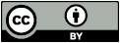
This work, except as identified below, is licensed by the Department of State Development and Infrastructure under a Creative Commons Attribution (CC BY) 4.0 Australia licence. To view a copy of this licence, visit creativecommons.org.au

You are free to copy, communicate and adapt this publication as long as you attribute it as follows:
© State of Queensland, the Department of State Development, Infrastructure and Planning, February 2025.

The licence does not apply to any branding, including the government coat of arms or government logos. Third party material that is not licensed under a Creative Commons licence is referenced within this document. All content not licensed under a Creative Commons licence is all rights reserved. Please contact the Department of State Development, Infrastructure and Planning/the copyright owner if you wish to use this material.


Translating and interpreting service
If you have difficulty understanding a document and need an interpreter, we provide access to a translating and interpreting service. You will not be charged for this service. To contact the Translating and Interpreting Service, telephone 131 450 and ask them to telephone the Department of State Development, Infrastructure and Planning on +61 7 3328 4811.

Disclaimer

The material published in this document is distributed by the Queensland Government as an information source only and is subject to change without notice.

The Queensland Government makes no statements, representations, or warranties about the accuracy, completeness or reliability of, and you should not rely on, any information contained in this document. You should make your own inquiries and obtain advice specific to your particular circumstances.

Despite our best efforts, the Queensland Government makes no warranties that the information in this online document is free of infection by computer viruses or other contamination.

To the extent permitted by law, the Queensland Government disclaims all responsibility and all liability (including without limitation, liability in negligence) for all expenses, losses (including direct and indirect losses), damages and costs you may incur as a result of the information in this document being inaccurate or incomplete in any way, and for any reason; or being subject to infection by computer viruses or other contamination.

Third-party websites

To the extent that there are any references or links to third-party websites contained in this document, you should be aware that third-party websites are not under our control and therefore we can make no representation concerning the content of these websites to you. The fact that we have referred you to these websites serve is not an endorsement by the State of Queensland of any of these websites.

References to third-party websites are provided only as a convenience to you. The Queensland Government does not warrant, guarantee or make any representation regarding the correctness, accuracy, reliability, currency, or any other aspect regarding characteristics or use of the information presented on third-party websites.

Where software is offered by a third-party website, you are advised that we may not have tested this software and therefore cannot make any representation regarding the quality, safety or suitability of any software found there. There are inherent dangers in the use of any software found on the Internet, and you are cautioned to make sure that you completely understand the risk before retrieving any software from the Internet.

Contact us
Å +61 7 3328 4811 or 13 QGOV (13 74 68)
@ info@dsdilgp.qld.gov.au
: www.statedevelopment.qld.gov.au
* PO Box 15009, City East, Queensland 4002
1 William Street, Brisbane 4000

Social Impact Evaluation
Chapter summary and recommendations:
- The social impact evaluation for the XXXX found that the project will address XXXX, improving long-term outcomes for XXXX.
- XXXXXXXXXXXXXXXX.
- Key positive impacts include:
  - XXXX.
  - XXXX
  - XXXX
  - XXXX
  - XXXX
  - XXXX
- While the XXXX is proposed to have significant positive impacts on stakeholders, negative impacts identified include:
  - XXXX.
  - XXXX
  - XXXX
- The majority of identified positive impacts had additional opportunities for enhancements. The suggested enhancements were designed to further improve XXXX, XXXX, XXXX.
- Mitigations to manage the negative impacts include effective communication and messaging and stakeholder engagement.
- Mitigation measures are suggested for all identified negative impacts, except for one impact rating. Two impacts were not able to be mitigated back to the project baseline, however two were able to extend beyond the baseline following mitigations.

Purpose
This chapter identifies the social value of the project, any relevant social impacts related to xxx and opportunities to enhance or mitigate them as well as recommending any possible enhancements for consideration. This Social Impact Evaluation (SIE) details a variety of impacts, including community, cultural, health, lifestyle, institutional, quality of life, economic and environmental impacts related to the project. The intent of this is to ensure all impacts are considered throughout the planning process, including current and future stages.
The following questions are answered by this chapter:
- what value will the project achieve?
- what negative impacts need to be mitigated and, when mitigated, what is the residual impact?
- what additional opportunities could be designed into the project to create additional value?

Approach
The SIE for the project has been conducted in line with the DSDIP’s SIE Guide, which is a supplement to the Business Case Development Framework (BCDF). The SIE Microsoft Excel Table has been completed and is included as Appendix X of this DBC.
Figure 1 illustrates how the SIE process was conducted. It was informed by inputs from:
- data and research supplied by XXXX
- desktop research, including news and social media reviews, and academic literature related to XXXX
- an SIE workshop with the project advisory team and key stakeholders from the XXXX
- discussions with project team advisors.
Figure 1 SIE Methodology
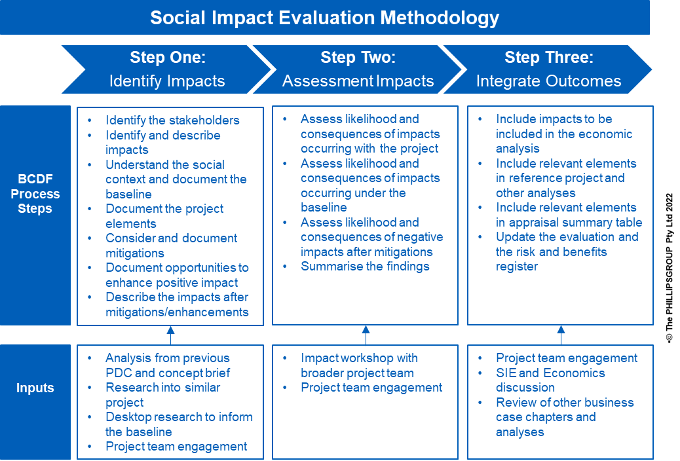
The development of these social impacts was done iteratively using the SIE Microsoft Excel tool provided as part of the BCDF templates. As new information was provided from stakeholders, desktop research and other advisors, the impacts were updated and changed.
Limitations to this SIE include the following:
- XXXX
- XXXX
- XXXX

Social Impact Baseline

Evaluation
The following social impacts were identified in line with the Queensland Government’s Business Case Development Framework (BCDF) SIE guidelines. The full SIE table is available in Appendix X, with further analysis and detail in the following sections of this chapter. A range of positive and negative impacts were identified across stakeholders, as well as across implementation and operational periods.
Table 2 below shows how stakeholders identified in the baseline are mapped against the identified impacts.
Table 2. Positive and negative impacts for each stakeholder, separated for implementation and operational phases.
Stakeholder | Impact during operation | Impact during implementation
Young people
 | Positive
 | Positive
 | Positive
 | Positive
General community

Positive impacts of the project
The following section details the positive impacts identified during the SIE, grouped by stakeholder groups. These are ordered from most impacted stakeholder to least impacted, with impacts also separated out by whether they are part of the operation of the facility, therefore reflecting the values of the project, or part of the implementation or construction of the facility.
The stakeholder groups identified for analysis are as follows, ordered from most to least impacted:
- XXXX
- XXXX
- XXXX
- XXXX

XXXX
XXXX
Table 3. Positive project impacts during operational phase on young people who have committed alleged offences.
Impact | Baseline | Elements of the project | Outcome of the project

General community
XXXX

Table 4. Positive project impacts during operational phase on the general community.
Impact | Baseline | Elements of the project | Outcome of the project
XXXX.
Table 5. Positive project impacts during implementation phase on the general community
Impact | Baseline | Elements of the project | Outcome of the project

XXXX
XXXX.
Table 6. Positive project impacts during operational phase on the XXXXX.
Impact | Baseline | Elements of the project | Outcome of the project

Staff
XXXX.
Table 7. Positive project impacts during operational phase on XXXX staff.
Impact | Baseline | Elements of the project | Outcome of the project

Negative impacts and their mitigations
Some negative impacts were identified during the SIE. The stakeholder groups identified for negative impacts are as follows, ordered from most to least impacted:
- XXXX
- XXXX
- XXXX

General community
XXXX.
Table 8. Negative project impacts during operational phase on the general community.
Impact | Baseline | Elements of the project | Outcome of the project
XXXX.
Table 9. Negative project impacts during operational phase on the general community.
Impact | Baseline | Elements of the project | Outcome of the project
XXXX.
Table 10. Negative project impacts during operational phase on the general community.
Impact | Baseline | Elements of the project | Outcome of the project

XXXX
XXXX.
Table 11. Negative project impacts during operational phase on XXXX.
Impact | Baseline | Elements of the project | Outcome of the project

Impact summary
The following radar graphs document the change between the baseline and the reference project.
Two radar graphs have been used for each stakeholder group to display the change between the baseline and the reference project, and again after enhancements and mitigations. It is important to note that project enhancements/mitigations are not included in the reference project and are utilised to document the optimal state of social impact that the project can have on stakeholders.
Where the impact rating is the same, only one colour is shown. For example, where the orange Project line shares the same path as the purple enhancement/mitigation line, only the purple is visible, indicating that the impact rating has not changed after enhancement or mitigation.

Positive impacts on young people
Figure 3 illustrates the value expected to be created by the project in relation to young people XXXX. Of the ten positive impacts on these young people, all impacts are significantly improved by the reference project, as identified by the change from baseline to the reference project.
Figure 4: Positive impacts with reference project - XXXX

Positive community impacts
XXXX.
Figure 5: Positive impacts with reference project – Community

Positive staff impacts
Figure 5 shows that all positive impacts on staff are improved by the reference project, with all having medium to high residual impact ratings in relation to the baseline.
Figure 6: Positive impacts with reference project – Staff

Negative impacts
The negative impacts radar graph (Figure 7) applies to stakeholders including the general community and XXXX. Figure 7 includes eight negative impacts across quality of life, community, lifestyle, economic, and institutional, legal and political categories.
As displayed in Figure 12, of the eight negative impacts of the project, only one is resistant to mitigation – ‘XXXX’. XXXX
Two negative impacts were unable to return to the impact rating of the baseline. ‘XXXXXX
XXXX
Two negative impacts were able to extend beyond and improve on the baseline of the project through effective mitigations. XXXX.
XXXX.
Figure 8: Negative impacts with reference project after mitigations

Impact opportunities
In addition to the value expected to be created by this project, several additional opportunities have been identified which are currently above and beyond the scope of the project itself, providing even further benefits to the impacted stakeholders.
Of the 13 positive impacts that enhancements were proposed for, three were able to leverage the impact category from a medium to a high impact.

XXXX
The opportunities to enhance positive impacts on XXXX is outlined below in Table 12 below.
Table 12. Impact opportunities and optimal impacts for young people who have committed alleged offences.
Impact | Impact (with project) | Proposed enhancement | Optimal impact
XXXX.
Figure 9: Positive Impacts to reference project after enhancements – XXXX

General community
The opportunities to enhance positive impacts on the general community is outlined in Table 13.
Table 13. Impact opportunities and optimal impact for the general community.
Impact | Impact (with project) | Proposed enhancement | Optimal impact
Figure 9 identifies that all impacts benefit from further enhancement XXXX.
Figure 10: Positive impacts after enhancements – Community

XXXX
The opportunities to enhance positive impacts to the XXXX are outlined below in Table 14 below.
Table 14. Impact opportunities and optimal impact for the XXXX.
Impact | Impact (with project) | Proposed enhancement | Optimal impact
XXXX.
Figure 11: Positive impacts with enhancements - XXXX

Staff
The opportunities to enhance positive impacts on XXX are outlined below in Table 15 below.
Table 15. Impact opportunities and optimal impacts for staff.
Impact | Impact (with project) | Proposed enhancement | Optimal impact
Two of the three impacts shown in Figure 11 were further improved by the enhancements – XXXX.
Figure 12-12: Positive impacts with reference project after enhancements – Staff

Integration
Table 16 below details how impacts and their mitigations or enhancements will be integrated within other sections of this business case.
Table 16. Integration of impacts into other business case chapters.
Impact | Project Element / Mitigation | Integration with Business Case

