1
STAGE 1:
Strategic Assessment
BUSINESS CASE DEVELOPMENT FRAMEWORK
Release 3

TEMPLATE

How to use this template
The Queensland Government provides templates to assist stakeholders in developing robust business cases for infrastructure proposals.
This template, its companion guide and supporting supplementary guides include considerations, assessment criteria and checklists to develop a strategic assessment aligned with the Business Case Development Framework. The contents of these documents are important to ensure the analysis supports a transparent and comparable investment proposal.
NOTE: This template is offered as a guide only. Applicable and suitable analysis should be fit-for-purpose considering the proposal complexity and risk, ensuring that rigorous and transparent processes are applied.
The following key content indicator has been included In a call-out box to help you use this template.

Reference

Target/expectation

Flag/important to note

  - Stage 1: Strategic Assessment

[Name of proposal]
[Proposal owner]
[Choose date]

Proposal summary
Name of proposal
Location of proposal
Proposal owner
Document date
Proposal description
Program name
Program description
Document control
Prepared by
Role title
Organisation
Phone number
Version history
Version no. | Date | Changed by | Nature of amendment
0.1 | 20/02/2020 |  | Initial draft

Contents
Executive Summary 6
1 Proposal overview (A1) 7
1.1 Proposal overview 7
1.2 Strategic governance 7
1.3 Assurance 7
1.4 Methodology 7
2 Stakeholders (A2) 8
2.1 Stakeholder engagement 8
3 Problem identification and service need (A3) 9
3.1 Understanding the problem/opportunity and documenting the service need 9
3.2 Consider relative importance 9
4 Targeted benefits (A4) 10
4.1 Consider relative importance 10
4.2 Timing considerations 10
4.3 Benefit statement 10
Health Check A 12
5 Risk (A5) 13
5.1 Identifying proposal risks 13
5.2 Identifying process risks 13
6 Strategic response and business changes (A6) 14
6.1 Strategic responses 14
6.2 Business changes 14
7 Potential initiatives (A7) 15
7.1 Document initiatives 15
7.2 Ranking criteria 15
7.3 Relative importance 15
Health Check B 16
8 Options generation (A8) 17
8.1 Approach 17
8.2 Options longlist 17
9 Next steps (A9) 18
9.1 Future activities 18
10 Recommendations (A10) 19
References 20
Health Check C 21
Appendix 1: Benefits register 22
Appendix 2: Risk register 23
Appendix 3: Stakeholder Engagement Plan 24
Appendix 4: Investment logic map and initiatives map 25

Executive summary
The executive summary of a Stage 1: Strategic Assessment should give an overview of the analysis you have undertaken and the key recommendations you have identified.
It should include a summary of:
- the service need and problem/opportunity statements
- the outcomes and benefits targeted
- the strategic responses considered
- the initiatives and process to develop an options longlist
- any linkages to other initiatives or activities within the agency or across government
- an overview of the analysis process used for initiatives, and longlist options, including alignment to benefits targeted and service need
- any limitations or constraints in the analysis presented
- next steps and recommendations for longlist options to be progressed to Stage 2: Options Analysis.
The executive summary should read as a stand-alone document and be as succinct as possible. It should only contain information relevant for decision-makers to decide whether to progress to Stage 2: Options Analysis.
Finalise the executive summary after you have completed the Stage 1: Strategic Assessment analysis.

- Proposal overview (A1)

  - Proposal overview
Clearly articulate and document the background to the service need, including the proposal, covering context, background, justification for government involvement, linkages to other initiatives, and relative importance of the service need.
  - Strategic governance
This section should describe the strategic governance arrangements for the proposal.
  - Assurance
Document any internal, external or independent assurance processes you have conducted as part of the development and completion of the Stage 1: Strategic Assessment e.g. internal or central agency consultation and peer reviews.
Consider a Gate 0 Gateway review on the basis that:
‘Gate 0 involves a review of an entire program, together with its constituent projects. It investigates the direction and planned outcomes of the program, together with the progress of its constituent projects. It can be repeated at key decision points throughout the life of the program.’
The results of a Gate 0 Gateway review should be incorporated into the analysis for the Stage 1: Strategic Assessment and note any material considerations in this section.
If you do not conduct a Gate 0 Gateway review at this stage, consider conducting one before beginning a Stage 2: Options Analysis.
  - Methodology
This section should describe your approach to developing the Stage 1: Strategic Assessment, including how you approached:
- identifying the service need, benefits, initiatives and longlist options
- risk management
- stakeholder engagement
- assurance arrangements.
Also note any limitations and constraints.
If you used an investment logic map (ILM) approach to develop the Stage 1: Strategic Assessment, note this in the methodology and give information on any changes to the process detailed in the Investment Logic Mapping Guide. Also note any issues that arose during the ILM.

- Stakeholders (A2)

  - Stakeholder engagement
You will identify stakeholders for your proposal as you progress through the Stage 1: Strategic Assessment.
Information in this section should include:
- stakeholders’ details—who they are, why and how they are interested, and the extent of their interest or influence
- stakeholders’ needs and expectations—both process and outcome, noting any needs or expectations that are mandatory
- the most appropriate engagement mechanism for each stakeholder or stakeholder group i.e. inform, consult or active participation
- any risks of engaging (or not engaging) with stakeholders and how these risks should be managed
- any conflicts or opportunities for collaboration between stakeholders.
In this section, document details of relevant stakeholders and how they have been engaged throughout the Stage 1: Strategic Assessment. Consider using the following example table.
Table 1: Sample stakeholder matrix
Stakeholder details | Stakeholder interest  (H, M, L) | Stakeholder influence  (H, M, L) | Summary of stakeholder engagement activities undertaken  (including how the stakeholder is affected, needs and expectations, ability to support achievement of the intended outcomes/benefits etc.)
A more detailed stakeholder engagement plan should be included as an attachment. See Appendix 3.
Further information on effective stakeholder engagement during proposal development is included in the Stakeholder Engagement Guide.

- Problem identification and service need (A3)

  - Understanding the problem/opportunity and documenting the service need
Write your problem/opportunity statements. The problems you identify at this stage should be supported by an ILM. See Appendix 4. For further guidance, see the Investment Logic Mapping Guide.
The service need should focus on the problem/opportunity itself and why is must be addressed, not on potential solutions. The problem statement and service need should read logically, tell a cohesive story, and not be overly repetitive.
Table 2: Sample statement of service need
Problem 1: [Insert your first problem statement here]
Describe the problem here, providing the required evidence to demonstrate this is a problem government must solve Explain the problem

Service need analysis
Provide high-level evidence of the service need

You can duplicate this table for each problem statement you generate.
Problems or opportunities you identify in the statement of service need must be supported by robust, transparent and detailed evidence. For example, demand analysis that would include methodology, key parameters, assumptions, sensitivity or scenario analysis and findings.
Consider establishing an initial business-as-usual base case, informed by the service need analysis for your Stage 1: Strategic Assessment, especially if you expect the proposal will proceed to a Stage 2: Options Analysis.
  - Consider relative importance
This section should outline any problems or opportunities with ranking to show a broad indication of their relative importance.

- Targeted benefits (A4)

This section should identify, quantify and document the benefits that will be achieved if the service need is met.
  - Consider relative importance
Benefits should be ranked in a similar way to the problem/opportunity outlined in Section 3.2. Some elements to consider include integration with other initiatives, risks, impact on stakeholders, and the scope of the benefit.
  - Timing considerations
This section should outline any timing considerations that may affect the ability to achieve a potential solution to the outlined service need or problem. Considerations may include:
- the timeframe for any potential impacts
- any urgency in responding to the problem or seizing the opportunity
- how the service need response aligns to any planned changes to the agency’s mission, vision and strategic priorities.
  - Benefit statement
The section should document the benefits targeted, providing an initial view of what benefits would be achieved by addressing the service need. Benefit statements should be supported by the investment logic map and benefits management plan.
This section should consider:
- the intended outcomes for the proposal and the benefits targeted by it
- the anticipated beneficiaries and identified stakeholders
- any assumptions that underpin the benefits targeted
- any identified and documented dependencies of the benefits targeted
- any urgency or critical factors affecting the intended outcomes and benefits targeted
- any potential disbenefits (adverse impacts) and risks to achieving the benefits targeted (this information should be included in the benefit and risk registers. See Appendices 1 and 2).
Table 3: Sample benefit identification and capture
Benefit 1: [benefit name]
Benefit description | Describe the benefit
Problem/opportunity statement | List the problem/opportunity statement this benefit is related to
Assumptions | Detail the assumptions underlying the benefits
Related stakeholder(s) | List stakeholders
Anticipated beneficiaries | List beneficiaries
Identified dependencies | List identified dependencies
Urgency of benefit | Assess urgency, high/medium/low
This table may be duplicated as required, depending on the number of benefits identified.

Health check A

Checklists are for your pre-submission use only; you do not need to include them in the final document.
Before progressing further with the Stage 1: Strategic Assessment, complete the following checklist. If you cannot complete an item, include an explanation in Section 1.4 Methodology.
# | Have you completed the following tasks? | Section | Completed
1 | Identified problems and opportunities | A3 | ☐
2 | Analysed cause and effects of problems and opportunities | A3 | ☐
3 | Identified, substantiated and clearly articulated the service need | A3 | ☐
4 | Explained the alignment to agency and government strategic priorities and planning | A4 | ☐
5 | Established the relative importance of the problems and opportunities | A4 | ☐
6 | Assessed the relative importance of the targeted benefits | A4 | ☐
7 | Created and begun a benefits register | Appendix 1 | ☐
8 | Created and begun a risk register | Appendix 2 | ☐
9 | Completed column 1 of the Investment Logic Map (if appropriate) | Appendix 4 | ☐

- Risk (A5)

  - Identifying proposal risks
This section should demonstrate that the potential initiatives and longlist options are designed to effectively address the risks associated with implementing them.
  - Identifying process risks
This section should consider stakeholder engagement activities and timing to ensure your development of the Stage 1: Strategic Assessment optimises potential outcomes and avoids unwarranted risk.
An example risk register is included in Appendix 2.

- Strategic response and business changes (A6)

This section should document the strategic responses and business changes you propose. They are the internal and external activities that would be needed to achieve the change.
  - Strategic responses
This section should describe high-level potential strategic responses (high-level intervention) that would meet the identified service need.
  - Business changes
This section should describe potential business changes (or enablers) that could be made to deliver the strategic responses.

- Potential initiatives (A7)

This section should document and clearly describe the potential initiatives. Potential initiatives are high-level activities to address the service need. They are suggested by the strategic responses and business changes. In future, potential initiatives may become options, projects or elements of a program, or be part of a base case consideration for further options analysis.
  - Document initiatives
Document the potential initiatives, including activities that:
- improve the use of an asset
- change behaviour or focus
- improve the capacity of an existing asset
- create a new asset.
These activities are often referred to as non-asset (including policy reform and/or better use), low cost capital and new asset solutions. Initiatives should align with the State Infrastructure Plan priorities, processes and categories.
  - Ranking criteria
Document the criteria you used to rank initiatives in this section. Criteria should be based on what is needed to successfully achieve the outcome targeted by the proposal.
  - Relative importance
Assess the relative importance of potential initiatives and rank them. This section should clearly outline the ranking process and outcome.

Health check B

Before progressing further with the Stage 1: Strategic Assessment, complete the following checklist.
If an item has not been completed, include an explanation in Section A1 (1.4) Methodology.
# | Have you completed the following tasks? | Section | Completed
1 | Identified stakeholders | A2 | ☐
2 | Documented stakeholder information | A2 | ☐
3 | Updated stakeholder engagement plan | A2 & Appendix 3 | ☐
4 | Identified and documented strategic responses | A6 | ☐
5 | Identified and documented business changes | A6 | ☐
6 | Identified and documented potential initiatives | A7 | ☐
7 | Identified, documented and assessed the benefits to be achieved by potential initiatives against the initial benefits targeted | A7 | ☐
8 | Assessed the relative importance of potential initiatives | A7 | ☐
9 | Documented criteria for success | A7 | ☐
10 | Demonstrated that potential initiatives are aligned with the State Infrastructure Plan | A7 | ☐
11 | Updated the benefits register | Appendix 1 | ☐
12 | Updated the risk register | Appendix 2 | ☐
13 | Completed the initiatives map | Appendix 4 | ☐

- Options generation (A8)

This section should document how you developed proposal options (solutions or initiative packages) from the potential initiatives you previously identified. These options will form the options longlist, which will be analysed in the Stage 2: Options Analysis, should this proceed.
Note that, in some cases, potential initiatives could be considered as part of the base case in Stage 2: Options Analysis. This could include initiatives such as regulatory or policy changes that have immediate or very near-term application.
This is a critical section as it gives clarity and understanding about the range of options that you are considering.
  - Approach
This section should outline the approach you have taken to develop the options longlist (and the initial base case). See a suggested approach in the Stage 1: Strategic Assessment Guide.
If you use the example approach, insert the respective table for developing longlist options as shown in the guide.
  - Options longlist
This section should summarise the options longlist. The complete details for the options longlist should be attached as an appendix to the Stage 1: Strategic Assessment.
Table 4: Sample options summary
option GENERATION Summary
Options longlist | STATE INFRASTRUCTURE PLAN category | Option description
Business-as-usual base case | [Category] | - Detailed description of initial base case
Option 1 – [Description] | [Category] | - [Detailed description of option]
Option 2 – [Description] | [Category] | - [Detailed description of option]
Option 3 – [Description] | [Category] | - [Detailed description of option]
Option 4 – [Description] | [Category] | - [Detailed description of option]
Option 5 – [Description] | [Category] | - [Detailed description of option]

- Next steps (A9)

This section of the Stage 1: Strategic Assessment focuses on the next steps, including a Stage 2: Options Analysis, if recommended.
  - Future activities
Document any future work that will be needed if the recommendation progresses to Stage 2: Options Analysis.
This section should also indicate the timeframe and urgency of any further work.
- Recommendations (A10)

The recommendation section should give clear details of further actions you propose (such as studies, investigations etc.) and what they will cost. Your recommendations should capture the potential coordinating and oversight mechanisms for future documentation and analysis.
If you recommend the proposal progresses, prepare a detailed plan and budget for the development of a Stage 2: Options Analysis to accompany the submission.

References

The completed Stage 1: Strategic Assessment should include a list of all references and sources of evidence you used to support the assessment.

Health check C

Before finalising the Stage 1: Strategic Assessment, complete the following checklist.
# | Have you completed the following tasks? | Section | Completed
1 | Outlined your approach to generating options | A8 | ☐
2 | Documented the options longlist | A8 | ☐
3 | Identified and documented any further work required | A9 | ☐
4 | Reviewed the completed Stage 1: Strategic Assessment to ensure it:  - is complete  - has reliable and reasonable information  - is transparent  - documents ownership clearly  - allows your assessments and documentation to be compared to others | – | ☐
5 | Documented recommendations | Recommendations | ☐
6 | Prepared a submission for the decision-maker | – | ☐
7 | Developed a detailed plan and budget for a Stage 2: Options Analysis (if appropriate) | – | ☐
8 | Included all reference sources supporting the Stage 1: Strategic Assessment in the reference list | References | ☐
9 | Updated and finalised the benefits register | Appendix 1 | ☐
10 | Updated and finalised the risk register | Appendix 2 | ☐
11 | Updated the initial stakeholder engagement plan | Appendix 3 | ☐

Benefits register

Benefits identified while developing your Stage 1: Strategic Assessment should be captured in a benefits register. At this stage, the benefits register should be used to make sure that strategic responses, business changes and potential initiatives address the targeted benefits. It also allows stakeholders’ needs to be incorporated in the design of the initiative.
Refine the benefits register when you develop the Stage 2: Options Analysis and Stage 3: Detailed Business Case.
Table 5: Sample benefit register
Initial Benefit register
Benefit description | Related to: (state problem/opportunity statement or potential initiative) | Related stakeholder/s | Potential beneficiary | Possible measures | Relative importance

Risk register

Risks identified while developing your Stage 1: Strategic Assessment should be captured in a risk register. At this stage, the risk register should be used to identify and shape strategic responses, business changes, potential initiatives, and to identify stakeholders. You should continue to add further details to the risk register as you develop the proposal. You will need to add further details to the risk register after completing the conceptualisation activities in the Stage 1: Strategic Assessment.
Table 6: Sample risk register
RISK register
Risk category | Risk description | Trigger | Impact | Likelihood | Consequence of risk | Risk rating | Control strategy
 | There is a risk that … | … caused by … | ... resulting in …
Delivery | There is a risk construction will be delayed | … caused by extended periods of rain | … resulting in an extended construction period that may affect … | Likely | Major | High | Ensure the project schedule includes sufficient float to account for potential weather delays
Demand | There is a risk local growth strategies may change under the newly elected local council | … caused by new local councillors having a stronger preference for urban containment | … resulting in lower traffic volumes and toll revenue | Possible | Moderate | Medium | Agency to keep in close and regular contact with council

Stakeholder engagement plan

A stakeholder engagement plan includes details of the stakeholders relevant to the service need and proposal who should be considered when developing the Stage 1: Strategic Assessment. The stakeholder engagement plan should document the methods and frequency with which stakeholders will be engaged. The plan is a living document and should be adjusted throughout the development of the Stage 1: Strategic Assessment.
If you choose not to engage with stakeholders during the development of a Stage 1: Strategic Assessment, you can use a draft stakeholder engagement plan as a register to document stakeholder interest in the initiative for use at later stages.
Table 7: Sample stakeholder engagement plan
Stakeholder name and contact information | Stakeholder interest  (H, M, L) | Interest or influence  (H, M, L) | Engagement mechanism | Risk rating | Risk mitigation

Investment logic map and initiatives map

If completed, the investment logic map (ILM) and initiatives map should be attached to the Stage 1: Strategic Assessment. Details of what these documents need to include can be found in the Investment Logic Mapping Guide and Benefits Management Guide.

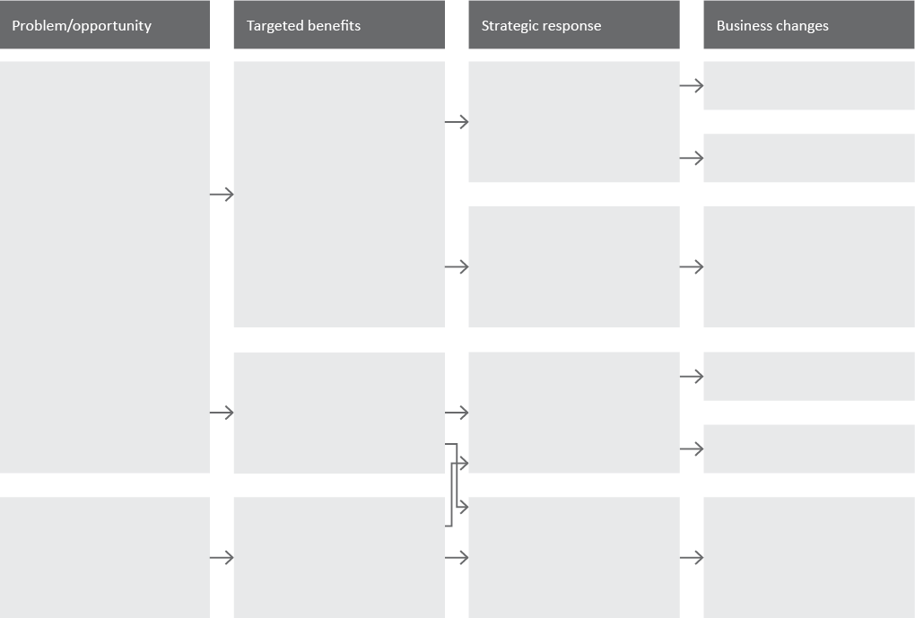
Figure 1: Sample investment logic map structure

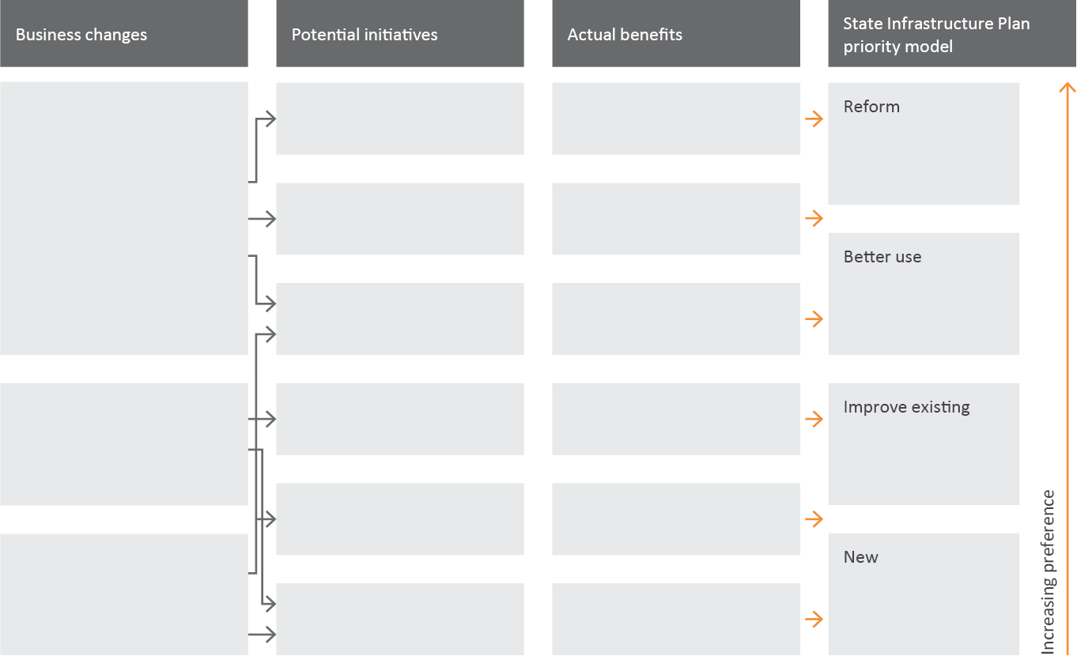
Figure 2: Sample initiatives map structure

Figure 3: Sample investment logic map structure
Figure 4: Sample initiatives map structure

[Proposal owner]
[Contact details]
[Contact details]
[Contact details]

